**DAILY ONLINE ACTIVITIES SUMMARY**

|  |  |  |  |  |  |  |  |
| --- | --- | --- | --- | --- | --- | --- | --- |
| **Date:** | **31-05-2020** | | | | **Name:** | **Harshitha M** | |
| **Sem & Sec** | **8th 'A'** | | | | **USN:** | **4AL16CS038** | |
| **Online Test Summary** | | | | | | | |
| **Subject** | | **IOT** | | | | | |
| **Max. Marks** | | **20** | | **Score** | | **18** | |
| **Certification Course Summary** | | | | | | | |
| **Course** | **Python for Machine learning** | | | | | | |
| **Certificate Provider** | | | **Great learning** | **Duration** | | | **3hr** |
| **Coding Challenges** | | | | | | | |
| **Problem Statement: 1) Python program to find sum of array**  **2) Python program to swap elements at given positions** | | | | | | | |
| **Status:Solved** | | | | | | | |
| **Uploaded the report in Github** | | | | **Yes** | | | |
| **If yes Repository name** | | | | **Harshitha-M** | | | |
| **Uploaded the report in slack** | | | | **Yes** | | | |

Online test details;(Attach the snapshot and briefly write the report for the same)

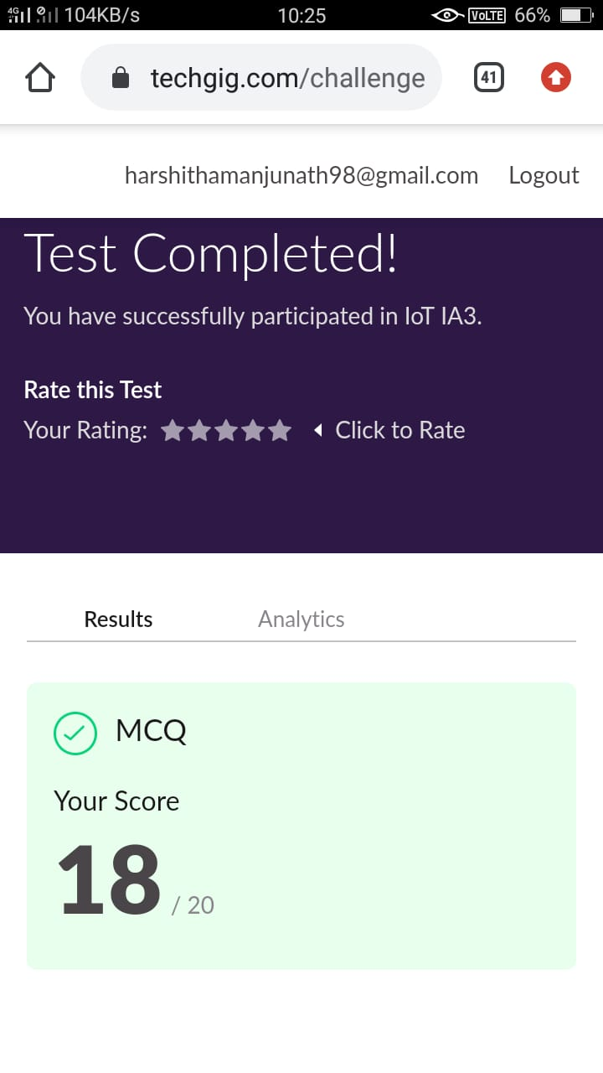

Certification Course Details: (Attach the snapshot and briefly write the report for the same)

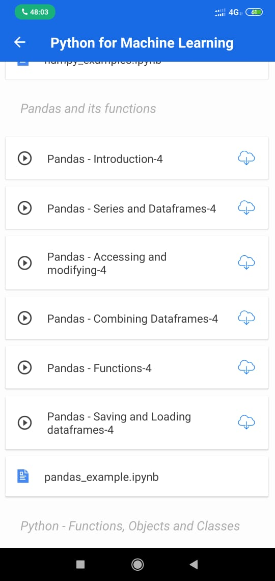

Online coding Detaills:

1) Python Program to find sum of array

def _sum(arr,n):

return(sum(arr))

arr=[]

arr = [12, 3, 4, 15]

n = len(arr)

ans = _sum(arr,n)

print ('Sum of the array is ', ans)

2) Python program to swap elements at given positions

def swapPositions(list, pos1, pos2):

list[pos1], list[pos2] = list[pos2], list[pos1]

return list

List = [23, 65, 19, 90]

pos1, pos2 = 1, 3

print(swapPositions(List, pos1-1, pos2-1))